900221-000-00-KM-04, Intermediate Programming Principles in Python, NQF Level 4, Credits 6
Facilitator Guide
Module Four (4)

Module Code | 900221-000-00-KM-04
NQF Level | 4
Credits | 6
Skills Programme ID Number | SP- 230375
Curriculum Title | Java Programmer
Curriculum Code | 900221-000-00-00

Name
Contact Address
Telephone (H)
Telephone (W)
Facsimile
Cellular
E-mail

Note to the learner
This Learner Guide provides a comprehensive overview of the module. It is designed to improve the skills and knowledge of learners, and thus enabling them to effectively and efficiently complete specific tasks.

Purpose of the Module
The main focus of the learning in this knowledge module is to build an understanding of the principles of intermediate programming with Python programming language
The learning will enable learners to demonstrate an understanding of:
- KM-04-KT01: Python Object Oriented Programming (OOP)25%
- KM-04-KT02: Fundamental concepts of Object-oriented programming20%
- KM-04-KT03: Basics of Algorithms10%
- KM-04-KT04: File handling20%
- KM-04-KT05: Exception handling25%

Provider Accreditation Requirements for the Knowledge Module
Physical Requirements:
- The provider must have lesson plans and structured learning material or provide learners with access to structured learning material that addresses all the topics in all the knowledge modules as well as the applied knowledge in the application.
- QCTO/ MICT SETA requirements

Human Resource Requirements:
Lecturer/learner ratio of 1:20 (Maximum)
- Qualification of lecturer (SME): o NQF 5 qualified in industry recognised qualifications with 1-year experience in the IT industry
- Cybersecurity vendor certification • Assessors and moderators: accredited by the MICT SETA

Legal Requirements:
- Legal (product) licences to use the software for learning and training
- OHS compliance certificate

Venue, Date and Time:
Consult your facilitator should there be any changes to the venue, date and/or time.Refer to your timetable.

Assessments
Integrated Formative Assessment: The skills development provider will use the curriculum to guide them on the stipulated internal assessment criteria and weighting. They will also apply the scope of practical skills and applied knowledge as stipulated by the internal assessment criteria. This formative assessment leads to entrance into the integrated external summative assessment.

Integrated Summative Assessment: An external integrated summative assessment conducted through the relevant QCTO Assessment Quality Partner is required to issue this qualification. The external integrated summative assessment will focus on the exit level outcomes and associated assessment criteria.

Skills Programme Rationale
In South Africa, according to the 2020 list of occupations in high demand: Technical Report (Department of Higher Education and Training) published in 2021 it is clear that the role of the programming and its derived skills programmes have been identified as pivotal by several Sector Education and Training Bodies (SETAs). Responding to the rapid skills demand by supplying Python programmers will thus have a positive impact on the economy.
Python programmers will play a pivotal role in establishing a data-driven culture and currently available advanced technology to manipulate these big data and complex datasets.
It is also important to note that there are great opportunities to become self-employed and the entrepreneurial orientated Python Programmers will form new companies (with the employment creation associated to it).
A demand for competent Python programmers exist in any economic sector, e.g. finance, insurance, healthcare, energy, environmental, government, transportation, agriculture and food. International research also confirms the phenomenal growth in the need for qualified programmers, including Python Programmers.
Typical learners include school leavers and persons who want to enter the ICT sector with programming skills. Minimum requirements are a Gr 11 with Maths Lit and English.

Skills Programme Purpose
A Python Programmer will be able to implement solutions to solve real-life problems in an efficient manner applying a knowledge and understanding of the principles of programming with Python and applicable tools.
Tasks that the learner will be able to know, do and understand after achievement of the skills programme include:
- Create well-written and readable Python programs, using a disciplined coding style, including comments and indentation standards.
- Work collaboratively in a team and execute version control.

Entry Requirements
- Grade 11 with Maths Lit and English.
- Access to equipment, internet connectivity and how to work remotely

EXIT LEVEL OUTCOMES

Exit Level Outcomes (ELO) 1
Describe the basics of Python Programming
Associated Assessment Criteria
- Fundamentals of the Python programming language are explained.
- The basic concepts and methods of object-oriented programming and object-oriented design are described.
- The development life cycle as a means of creating applications is described.

Exit Level Outcomes (ELO) 2
Programme effectively using Python frameworks and functionalities
Associated Assessment Criteria
- The use of Python syntax, using the Python API is applied.
- Well-written and readable Python programs are created, using a disciplined coding style, including documentation and indentation standards.
- The ability to troubleshoot problems with application development is applied.

Exit Level Outcomes (ELO) 3
Work collaboratively in a team using GitHub platform
Associated Assessment Criteria
- An ability to work with Git and GitHub functionalities is demonstrated.
- The ability to work collaboratively in a team using Git is applied
- Version control is executed using Git functionalities such as repositories, branches, commits and pull requests.

Session 1: KM-04-KT01: Python Object Oriented Programming (OOP)25%
- IAC0101 Explain the definitions, functions and features of Python OOP


Concept: Object-Oriented Programming (OOP) is a programming paradigm that uses objects and classes for organizing code. It is based on the concept of objects, which are instances of classes. Objects have both data (attributes) and methods (functions) associated with them. OOP promotes modularity, reusability, and a structured approach to software development.
Definition: Python is a multi-paradigm programming language, and it supports OOP. In Python, everything is an object, and you can create your own custom objects and classes. A class is a blueprint for creating objects, while an object is an instance of a class. Classes define attributes (data) and methods (functions) that the objects of the class will have.
Functions of Python Object-Oriented Programming:
- Encapsulation: Encapsulation is the bundling of data (attributes) and methods (functions) that operate on the data into a single unit, called a class. It restricts direct access to some of an object's components, providing data hiding and implementation security.
- Abstraction: Abstraction is the process of simplifying complex reality by modeling classes based on the essential characteristics of an object. It allows you to focus on what an object does rather than how it does it, making the code more manageable.
- Inheritance: Inheritance is a mechanism that allows one class (the child or subclass) to inherit the properties and methods of another class (the parent or superclass). This promotes code reusability and enables you to create specialized classes from more general ones.
- Polymorphism: Polymorphism allows objects of different classes to be treated as objects of a common superclass. It enables you to write code that can work with objects of multiple classes in a consistent way. Polymorphism is often achieved through method overriding and method overloading.
- Modularity: OOP encourages modular programming by breaking down complex systems into smaller, more manageable classes and objects. Each class is responsible for a specific aspect of the system, making it easier to understand, maintain, and extend the codebase.
- Code Reusability: OOP promotes code reusability through inheritance and the creation of reusable class libraries. You can build upon existing classes and customize them to suit your specific needs, reducing the amount of code duplication.
In Python, you can create classes and objects using the class keyword, define attributes and methods, and then use those objects to model real-world entities and solve complex problems in a structured and organized manner following the principles of OOP.

Session 2: KM-04-KT02: Fundamental concepts of Object-oriented programming20%
- IAC0201 Describe the use of fundamental concepts of OOP

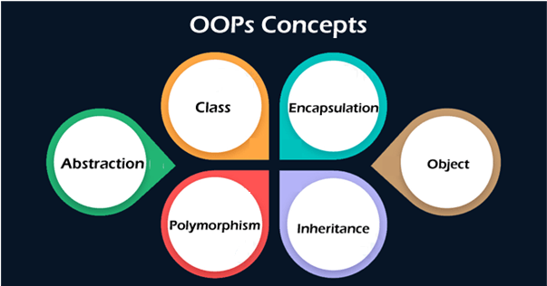
The fundamental concepts of Object-Oriented Programming (OOP) are a set of principles and ideas that form the foundation of OOP. These concepts help in organizing and structuring code in a more modular, maintainable, and reusable way. Here's an overview of the key concepts:
1. Objects:
- Concept: Objects are instances of classes that represent real-world entities or concepts in your code.
- Definition: An object is a self-contained unit that encapsulates both data (attributes) and behaviors (methods).
- Functions: Objects allow you to model and manipulate real-world entities in a structured and modular manner, promoting code reusability and maintainability.
2. Classes:
- Concept: Classes are blueprints or templates for creating objects. They define the structure and behavior of objects.
- Definition: A class is a user-defined data type that contains attributes and methods.
- Functions: Classes help you define a common structure and behavior for a group of objects. They enable you to create and manage objects easily and consistently.
3. Encapsulation:
- Concept: Encapsulation is the bundling of data (attributes) and methods (functions) that operate on that data into a single unit (a class).
- Definition: It restricts direct access to some of an object's components, providing data hiding and implementation security.
- Functions: Encapsulation promotes data integrity, allowing controlled access to an object's data through methods. It prevents unauthorized modifications and enhances code maintainability.
4. Inheritance:
- Concept: Inheritance is a mechanism that allows one class (the child or subclass) to inherit properties and methods from another class (the parent or superclass).
- Definition: It enables the creation of a new class by reusing and extending the features of an existing class.
- Functions: Inheritance promotes code reusability and the creation of specialized classes. It helps model "is-a" relationships and hierarchies among classes.
5. Polymorphism:
- Concept: Polymorphism allows objects of different classes to be treated as objects of a common superclass.
- Definition: It enables you to write code that can work with objects of multiple classes in a consistent way.
- Functions: Polymorphism is often achieved through method overriding and method overloading. It promotes flexibility in code design.
6. Abstraction:
- Concept: Abstraction is the process of simplifying complex reality by modeling classes based on the essential characteristics of an object.
- Definition: It focuses on what an object does rather than how it does it, hiding the unnecessary details.
- Functions: Abstraction helps in managing the complexity of large software systems, making code more understandable and maintainable.
7. Modularity:
- Concept: Modularity is the practice of breaking down complex systems into smaller, more manageable parts (classes and objects).
- Definition: It promotes the separation of concerns and the organization of code into reusable modules.
- Functions: Modularity enhances code maintainability, scalability, and collaboration among developers. It allows for easier debugging and testing.
These fundamental concepts of OOP provide a framework for designing and structuring software systems in a way that promotes code reusability, maintainability, and scalability while modeling real-world entities and relationships effectively.

Session 3: KM-04-KT03: Basics of Algorithms10%
- IAC0301 Determine the definitions, functions and features of Python algorithms

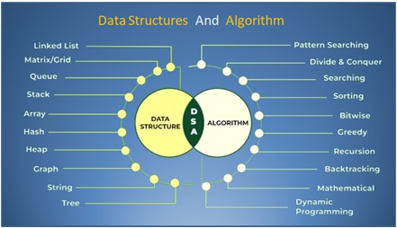
Basics of algorithms refer to the fundamental principles and concepts that underlie the design and implementation of algorithms. An algorithm is a step-by-step procedure or set of rules for solving a specific problem or performing a particular task. Here's a breakdown of the concept, definition, and functions of the basics of algorithms:
Concept:
- Algorithms: Algorithms are precise, unambiguous instructions for solving problems and performing tasks. They are fundamental to computer science and programming, as they define the logic and steps needed to achieve a specific goal.
Definition:
- Algorithm Definition: An algorithm is a finite sequence of well-defined, executable steps that provide a solution to a problem or a specific task. Algorithms take inputs, process them, and produce outputs.
Functions:
- Problem Solving: Algorithms are a fundamental tool for problem-solving. They provide a systematic approach to breaking down complex problems into manageable steps.
- Efficiency: Algorithms can be analyzed for their efficiency in terms of time and space complexity. Efficient algorithms are essential for optimizing resource usage and performance.
- Reusability: Well-designed algorithms can be reused in different contexts and applications, reducing the need to reinvent solutions for similar problems.
- Abstraction: Algorithms abstract the solution to a problem, focusing on the high-level steps and logic while hiding implementation details.
- Standardization: Algorithms provide a standardized way of describing and communicating solutions to problems, making it easier for programmers and researchers to collaborate.
- Automation: Algorithms enable automation by defining the logic for automated processes, such as sorting, searching, or data manipulation.
- Verification: Algorithms can be tested and verified for correctness, ensuring that they produce the expected results for a given set of inputs.
- Algorithmic Thinking: Learning and applying algorithms develop algorithmic thinking skills, which are valuable for solving a wide range of computational and real-world problems.
- Data Structures: Algorithms often work in conjunction with data structures to efficiently store and manipulate data. Understanding algorithms is crucial for selecting the appropriate data structure for a given problem.
- Optimization: Algorithms can be optimized and fine-tuned to improve their performance, reducing execution time or memory usage.
Examples of basic algorithms include sorting algorithms (e.g., bubble sort, merge sort), searching algorithms (e.g., binary search, linear search), and mathematical algorithms (e.g., Euclidean algorithm for finding the greatest common divisor).
Algorithms play a central role in computer science, software development, and various other fields where problem-solving and automation are required. A deep understanding of algorithmic principles is essential for building efficient and effective software systems and solving a wide range of computational problems.

Session 4: KM-04-KT04: File handling 20%
- IAC0401 Explain the definitions, functions and features of file handling in Python

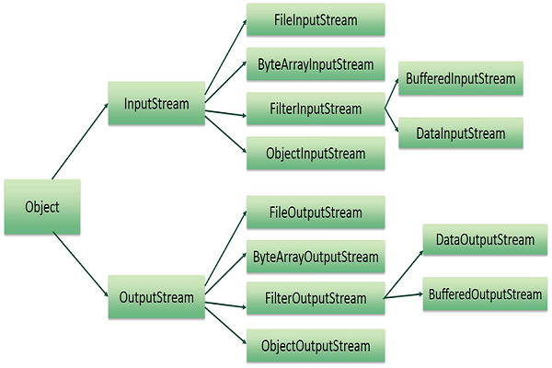
Concept: File handling, also known as file I/O (Input/Output), is a fundamental concept in computer programming and software development. It refers to the process of reading from and writing to files stored on a computer's storage device, such as a hard drive, solid-state drive, or external storage medium. File handling allows programs to interact with persistent data, which can be stored and retrieved across different program executions.
Definition: File handling involves managing files as part of a computer program's operation. It includes various operations such as creating, opening, reading, writing, updating, and closing files. These operations are crucial for applications that need to store and retrieve data for later use.
Functions:
- File Creation: File handling enables the creation of new files. This is useful for applications that need to generate and store data.
- File Opening: Programs can open existing files to read or modify their contents. Files can be opened in various modes, such as read-only, write-only, or read-write, depending on the desired access.
- File Reading: File handling allows programs to read data from files. Reading may involve reading the entire contents of a file or reading data line by line.
- File Writing: Programs can write data to files, allowing them to store information for future reference. Data can be written to files in various formats, including text, binary, or in a structured format like JSON or XML.
- File Updating: When files need to be modified, file handling provides the capability to update their contents. This is often done by reading the file, making changes in memory, and then writing the updated data back to the file.
- File Closing: After reading from or writing to a file, it's essential to close the file properly. Closing a file ensures that resources associated with the file are released and that changes are saved.
- Error Handling: File handling also involves error handling to manage exceptions and unexpected situations, such as file not found, permission issues, or disk full errors.
- File Management: File handling includes file management tasks such as renaming, moving, and deleting files. These operations allow programs to organize and manage files efficiently.
- Serialization and Deserialization: In addition to basic file I/O, file handling can be used for serialization (converting objects into a format that can be saved to a file) and deserialization (reading objects from a file and reconstructing them in memory).
- Data Persistence: File handling provides a means to persist data between program runs. For example, configuration settings or user data can be stored in files and retrieved when the program restarts.
- Working with Different File Formats: File handling allows programs to work with various file formats, including plain text files, CSV files, JSON files, XML files, binary files, and more.
File handling is a critical part of software development, as it enables programs to interact with external data and store information for various purposes, including data storage, configuration management, logging, and data exchange with other applications. Different programming languages provide libraries and functions to facilitate file handling operations, making it an essential skill for developers.

Session 5: KM-04-KT05: Exception handling25%
- IAC0501 Define the functions and features of Python exception handling

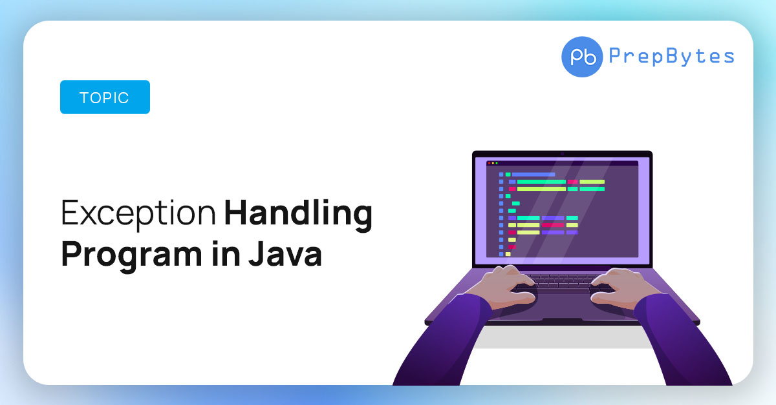
Exception handling is a programming concept and technique used to manage and respond to errors and unexpected situations that may occur during the execution of a program. Exceptions are events or conditions that disrupt the normal flow of a program and can lead to program crashes if not handled properly. Exception handling allows developers to gracefully handle these situations, recover from errors, and ensure that a program continues running even when unexpected issues arise.
Here are the key components and functions of exception handling:
1. Concept and Definition:
- An exception is an event that occurs during the execution of a program that disrupts the normal flow of instructions.
- Exception handling is the process of detecting, managing, and responding to exceptions in a way that prevents program termination or data loss.
- Exception handling helps improve program robustness, reliability, and maintainability by handling errors gracefully.
2. Functions of Exception Handling:
- Error Detection: Exception handling detects errors and exceptional conditions as they occur in a program's execution. These conditions can include runtime errors, input validation issues, resource unavailability, and more.
- Error Reporting: Exception handling provides a mechanism to report information about the error, such as an error message, stack trace, or additional context, to aid in debugging and diagnosing the issue.
- Error Handling: Exception handling allows developers to specify how to handle exceptions when they occur. This can involve various actions, such as recovering from the error, logging it, displaying an error message to the user, or gracefully terminating the program.
- Program Continuity: One of the primary goals of exception handling is to ensure that a program continues running despite encountering exceptions. Well-handled exceptions prevent program crashes and data corruption.
- Cleanup: Exception handling can be used to perform cleanup operations, such as releasing resources (e.g., closing files or network connections) or rolling back transactions, before the program exits or proceeds.
3. Exception Handling Mechanisms:
- Try-Catch (Try-Except): Most programming languages provide a try block where you place code that may generate exceptions. If an exception occurs within the try block, it is caught and handled in a corresponding catch (or except) block.
- Throw (Raise): Developers can explicitly throw exceptions when they encounter exceptional conditions. This allows custom exception types and messages to be created and handled.
- Finally (Ensuring): Some languages support a finally block that is executed regardless of whether an exception is thrown or caught. This is useful for cleanup tasks.
4. Examples of Common Exceptions:
- Divide-by-zero errors.
- File not found exceptions.
- Invalid input or data format errors.
- Network communication errors.
- Memory allocation failures.
- Database connection errors.
- Custom exceptions created for specific application logic.
5. Handling Multiple Exceptions:
- Languages often support handling multiple exceptions and specifying different error-handling logic for each type of exception. This allows fine-grained control over error handling.
6. Exception Propagation:
- Unhandled exceptions can propagate up the call stack, potentially causing the program to terminate. Exception handling can be used to catch and handle exceptions at appropriate levels in the call hierarchy.
Exception handling is a crucial aspect of writing robust and reliable software. It helps programmers anticipate and manage unexpected situations, improving the overall quality and stability of software applications.

